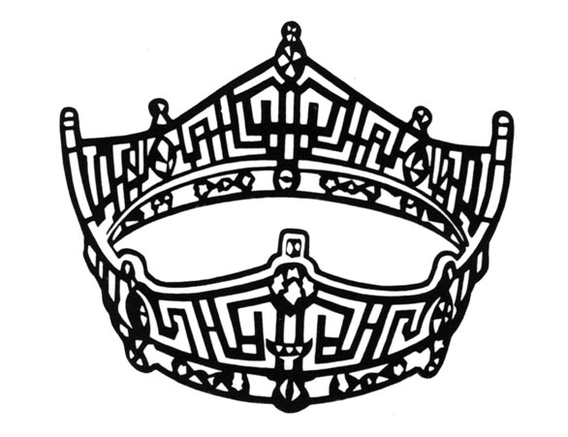
Miss Bucks County, Miss Montgomery County, and the
Miss Liberty Bell Scholarship Organization
Sponsorship Invitation
_____Yes! I would like to make a Scholarship Contribution!
_____Yes! I would like to make an In-Kind Donation for the 6 winners.
_____ GOLD SPONSOR $750+ (Full Page Ad, 4 appearances at sponsor’s event, 4 Pageant Tickets)
_____ SILVER SPONSOR $500-749 (Half Page Ad, 2 appearances, 2 Pageant Tickets)
_____ BRONZE SPONSOR $250-499 (Quarter Page Ad, 1 appearance, 1 Pageant Tickets)
_____ GENERAL SPONSOR $25-249 (Listing in program book and public acknowledgement during pageant production)
Advertising Invitation
_____Yes! I would like to buy Advertisement Space in the pageant program book!
Please mail your ad design with this form or e-mail it to MissBCMCLBorg@gmail.com.
_____ $100.00- Full page
_____ $75.00- 1/2 page
_____ $ 50.00- 1/4 page
_____ $ 25.00- Business card
Please consider making a donation to the Miss Bucks County, Miss Montgomery County, Miss Liberty Bell Scholarship Program, to help support the scholarship fund provided to young women in pursuit of college education. 100% of the money raised from this raffle will go towards the Miss Bucks County, Miss Montgomery County, Miss Liberty Bell Scholarship Fund.

Miss Bucks County, Miss Montgomery County, and the
Miss Liberty Bell Scholarship Organization
Sponsor & Ad Form
_____Yes! I would like to buy Advertisement Space in the pageant program book!
_____Yes! I would like to make a Scholarship Contribution!
_____Yes! I would like to make a In-Kind Donation for the winners.
Sponsorship Donation:

_____ GOLD SPONSOR $750+ up
_____ SILVER SPONSOR $500-$749
_____ BRONZE SPONSOR $250-$499
_____ GENERAL SPONSOR $25-$249

Kind of Ad in Program Book:

_____ $100.00- Full page
_____ $75.00- 1/2 page
_____ $ 50.00- 1/4 page
_____ $ 25.00- Business card

Amount of Sponsored/Ad Donation: $______________________ In-Kind Donation Worth $______________________
Description of In-kind Donation:____________________________________________________________________________
BUSINESS/ORGANIZATION:___________________________________________________________
CONTACT PERSON: (Name &Title) _______________________________________________________
ADDRESS: ___________________________________________________________________________
E-MAIL:____________________________________________ PHONE: ________________________
Make Checks Payable to:
Miss Bucks County, Miss Montgomery County, and Miss Liberty Bell Scholarship Organization
Mail completed form and payment by March 11th, 2017 to:
CEG Performing Arts Academy c/o Cristina Elena Guzman
684 North Broad Street -2nd floor - Philadelphia PA 19130

